About the Instructor
Ann Simon is a PATH International (Professional Association of Therapeutic Horsemanship) Certified Instructor and founder of Helping Hooves Equine Therapy Program.
Ann has had a solid background in horsemanship from a very young age. She grew up on her parent’s 17 acre farm in Washington State. Ann began showing at age 11 in 4H, FFA, Rodeo and Open Shows in events including Western and English Performance (Pleasure, Equitation, Trail), Gymkhana, Reining and Rodeo Drill team. In addition, friends of her family operated a therapeutic riding program and she began volunteering there at a young age.
When she moved to California, she continued to volunteer for a therapeutic riding program and eventually getting her teaching certification.
Ann has been teaching horseback riding lessons for nine years and therapeutic lessons for four years. She loves knowing she has helped her students grow and every day she gets to watch a student’s confidence and strength improve!

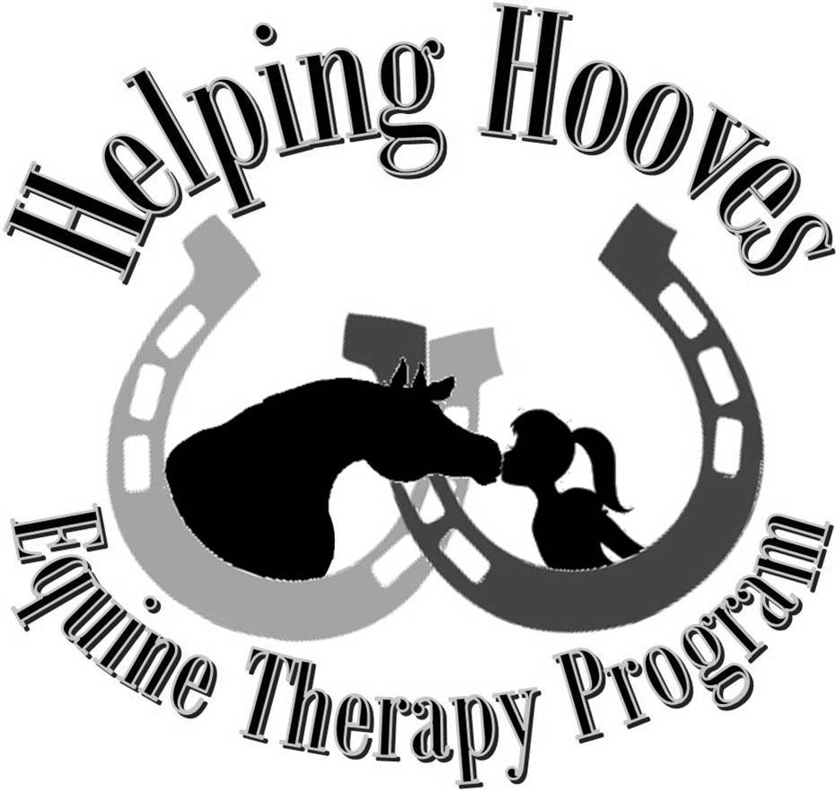

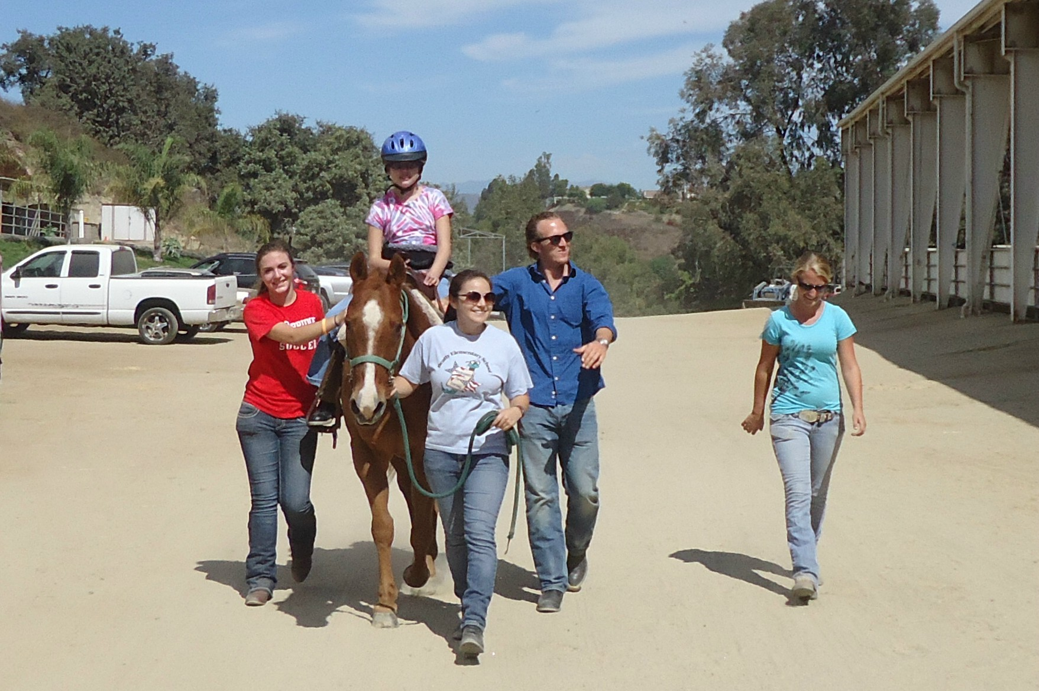
 Contact: Ann Simon Phone: 310-697-6850 (Cell)
Website: www.HelpingHooves.org Email: Ann@HelpingHooves.org
Ranch Location: Anaheim Hills Saddle Club
6352 East Nohl Ranch Road
Anaheim, CA 92807
I saw a child who couldn't walk, sit on a horse and laugh and talk.....I saw a child who could only crawl, mount a horse and sit up tall.....I saw a child born into strife, take up and hold the reins of life....And that same child was heard to say, thank you God for showing me the way. -John Anthony

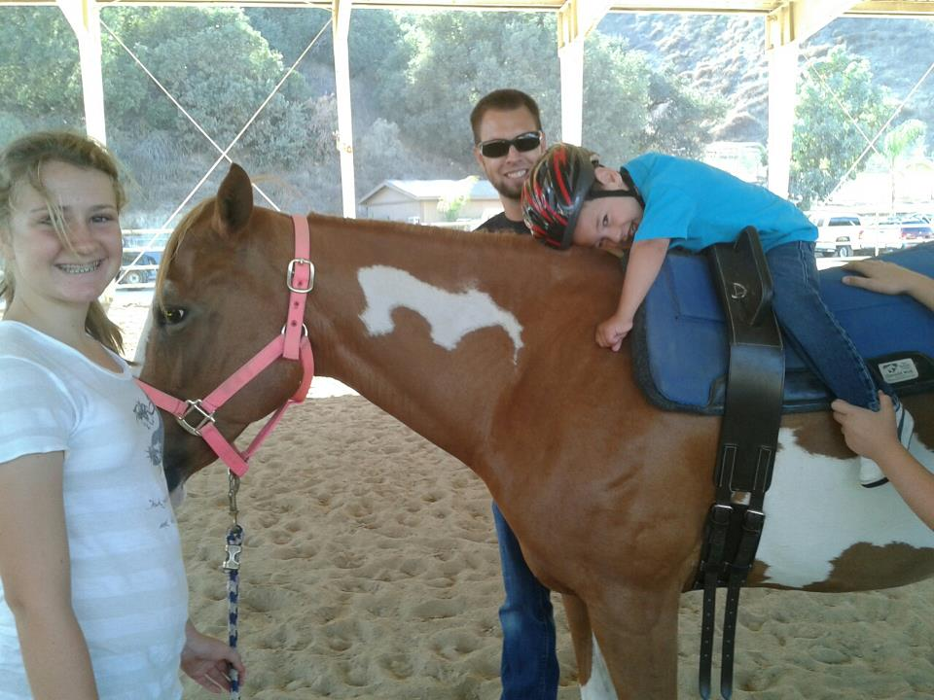

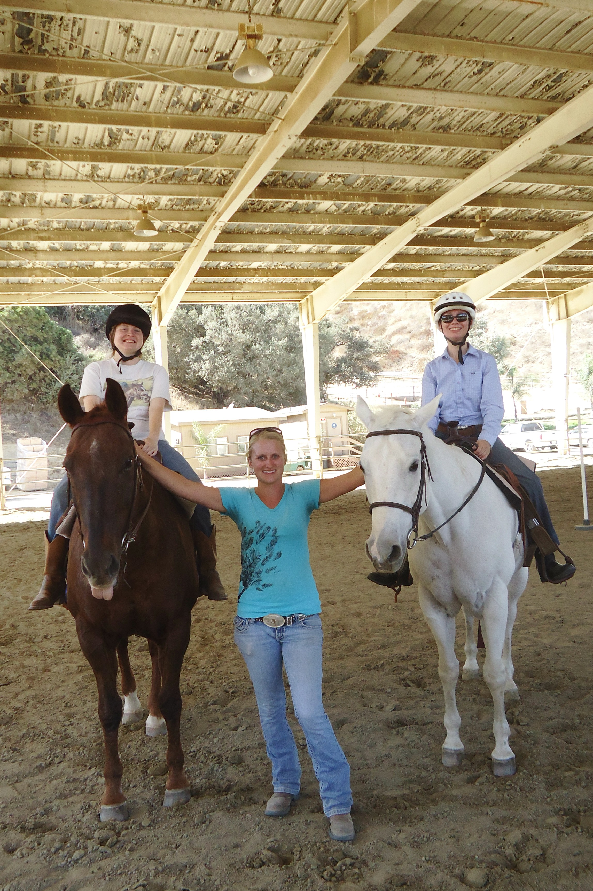
There is something about the outside of a horse that is good for the inside of a man. ~Winston Churchill
ANAHEIM HILLS SADDLE CLUB

Therapeutic Horseback Riding
Volunteer Opportunities
Western Horsemanship Lessons
Horse training
Horse Camps, Clinics and Parties
Horse shows

Therapeutic Riding or Equine Assisted Therapy is the use of the horse as a therapy tool to achieve goals including cognitive, physical, emotional, social, educational and behavioral goals as well as learning horseback riding skills
The horse is an effective therapy tool because the horse’s movement simulates a normal human gait. This gentle rhythmic movement helps improve balance, muscle control and tone, motor development and coordination, balance, posture, strength and overall body awareness.
Therapeutic riding offers a motivational opportunity to improve attention span, concentration, memory, and language skill development. The positive horse and human interaction can result in a greater sense of teamwork, self-esteem, responsibility and communication.
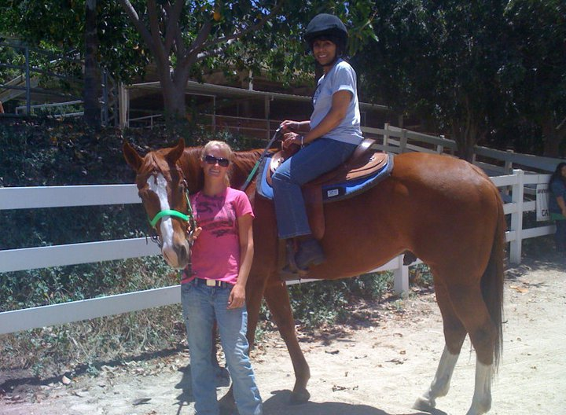

I enjoy therapy riding so much, that I wish I could ride every day! I also think so highly of the volunteers and Ann. All of you are simply awesome! Thank you from the bottom of my heart. – Lynne Woods, Therapy Student
Western Horsemanship Lessons:
Helping Hooves offers Western Horsemanship lessons for ages 3 and up!. Whether you are a complete beginner who wants to learn more about these magnificent animals or are an experienced rider that wants to continue riding or get into showing, we can help you get there! We have gentle, well trained school horses for all levels. Ask about are Summer Horsemanship Camps too!

Therapeutic Riding

Horse Leasing:
Riders ready for the responsibility of caring for a horse but don’t have the affordability of owning are placed into our leasing program. We have fun, safe, and friendly horses available to take you trail riding, barrel racing, and cattle sorting any day of the week! These rates are based on 3 hour sessions and availability for each horse will vary. Tack is included!
- $150/month for one day per week
- $250/month for two days per week
- $350/month for three days per week

Volunteering
Want to learn more about horses and help out a good cause? Helping Hooves is in need of hardworking volunteers ages 13 and up to groom, tack, lead and sidewalk our therapy horses as well as do various barn chores. Horse knowledge is helpful, but not required, training is available.
Volunteers also are able to get lessons at a discount price (at least 3 hours volunteering a week or 12 hours per month)! Volunteers are vital to the program, without volunteers, Helping Hooves could not operate.

Helping Hooves is such an incredibly beneficial program - to mind, body and spirit. Ann is a highly experienced and knowledgeable instructor with a great big heart at the root of it all.
–Nicole Falconer, Volunteer

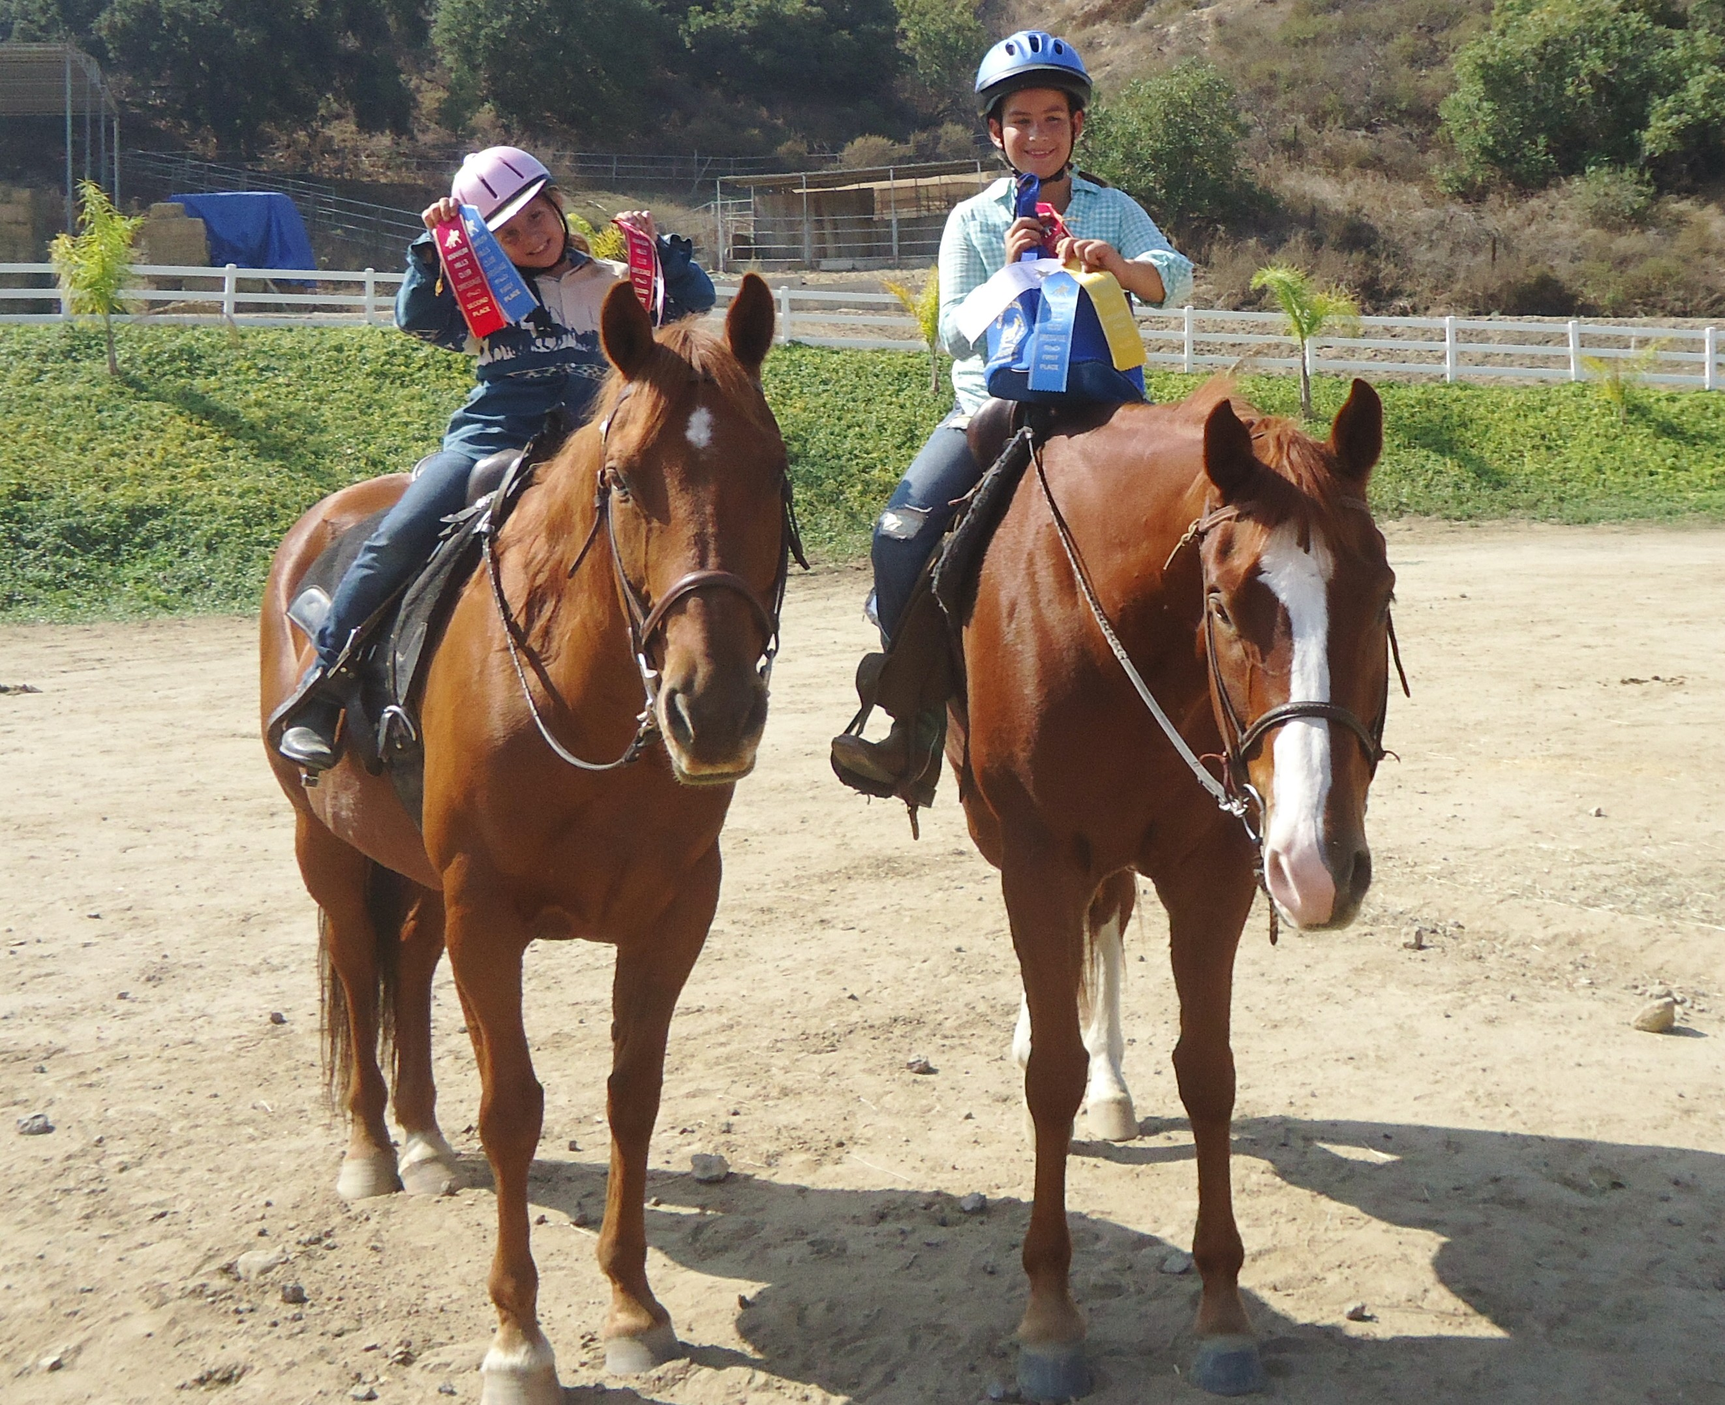
I wanted to extend my deepest gratitude for your expertise and patience working with Jamie. She has gotten so much joy and a real sense of accomplishment from training with you and building relationships with the horses. We all feel very fortunate to know you and about your program. -- Sue Rush, parent of student

Pricing
Therapeutic Horsemanship:
- $40/half hour semi-private lesson*
- $45/half hour private lesson
- $50/45 min semi-private lesson*
- $55/45-min private lesson
*Semi-private lessons have 2 to 3 students per instructor. Each rider is supervised closely by the instructor and trained volunteers.
Standard Horsemanship Lessons: On Lesson Horses:
- $60/hr Private Lessons
- $40/half hour private lessons
- $50/hr Semi-Private (2 riders)
- $40/hr Group Lessons (3-4 riders)
- $50/hr Trail Ride
- $10 for pony ride around ranch
Volunteer Lessons and Lessons on Student’s Owned or Leased Horse:
- $40/hr Private Lesson
- $30/half hour Private Lesson
- $35/hr Semi-Private Lesson
- $30/hr Group Lesson

Packages and Discounts for all lessons:
- Pay Month to Month: $10 off per month
- Refer a Friend: Save $10
- Buy 10 lessons- Save $50
- Family discount: Save $5 per family member
- Talk to Ann about other payment plans or discounts if needed, we don’t want to leave anyone out because of finances!

Horse Care and Training:
$5 per turnout
- $10 turnout and lunge
- $25/hr ground work or riding
Other Services:
- Rent Horse For Show: $50-$100 depending on length of time and location of show.
- Birthday Party $400 for 3 hours

